Colour by numbers: The ABC
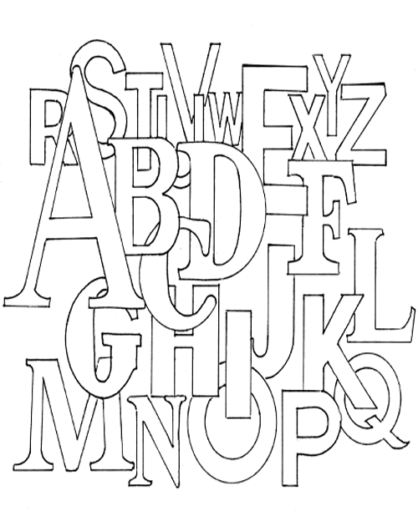

Colour the a red. Colour the j grey. Colour the s white.
Colour the b blue. Colour the k purple. Colour the t brown.
Colour the c green. Colour the l red. Colour the u grey.
Colour the d yellow. Colour the m blue. Colour the v purple.
Colour the e orange. Colour the n green. Colour the w red.
Colour the f pink. Colour the o yellow. Colour the x yellow.
Colour the g black. Colour the p orange. Colour the y green.
Colour the h white. Colour the q pink. Colour the z blue.
Colour the i brown. Colour the r black.

